

**TRANSPORT E-BOOKING WEBSITE**

**Software Requirement Specification**

– Ho Chi Minh, September 2022 –

**Table of Contents**

I. Overview 3

1. Introduction 3

2. System Functions 4

a. Screen flow 4

b. Screen details 5

c. User authorization 6

d. Non-screen functions

3. Common Requirements 6

II. Functional Requirements 6

1. Login & Sign-up 7

2. Purchase a trip or rent a car

3. Manage profile (customer)

4. Manage transports (company)

5. Manage data (admin) 6

# I. Overview

## 1. Introduction

The Transport E-Booking website is a new e-commerce website specialising in giving users a new way to book a trip or rent a car for yourself. Having a means of transportation can never more be easy, just a few clicks and you have got yourself a trip or a car for your own uses.

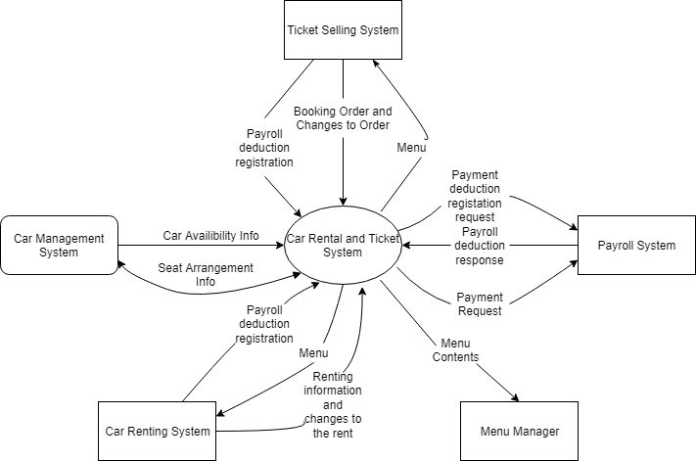

## 2. System Functions

#### a. Screen Flow

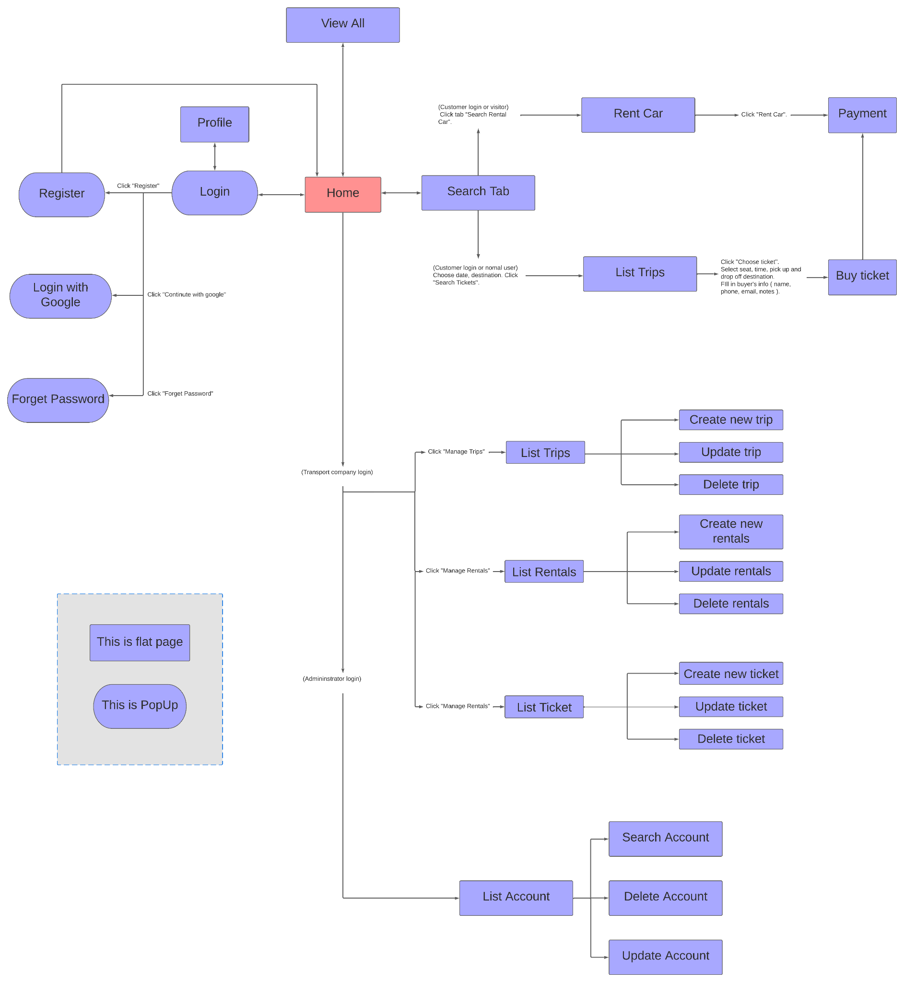

#### b. Screen Details

| **#** | **Feature** | **Screen** | **Description** |
| --- | --- | --- | --- |
| 1 | Home | Home | Default home screen, always accessible |
| 2 | Login | Login, Home | User can login with registered or google account, create new account , reset password and log out |
| 3 | Manage profile | Profile | Customer can change their account’s information |
| 4 | Search rental cars | Search | Users and customers can search for rentals cars |
| 5 | Search trips | Search | Users and customers can search for trips. |
| 6 | View all trips | View All | Users and customers can view all trips |
| 7 | View all rental cars | View All | Users and customers can view all rental cars |
| 8 | Payment | Payement | Customer choose transaction type to purchase ticket |
| 9 | Manage Trips | List Trips | Transportation company manages their trips |
| 10 | Manage Rental Cars | List Rentals | Transportation company manages their rental cars |
| 11 | Manage Vehicles | List Vehicles | Transportation company manages their vehicles |
| 12 | Manage Tickets | List Tickets | Transportation company manages their tickets |
| 13 | Manage Accounts | List Account | Page’s administrator manages all accounts |

#### c. User Authorization

| **Screen** | **Guest** | **Customer** | **Transportation Company** | **Admin** |
| --- | --- | --- | --- | --- |
| Home | X | X | X | X |
| Login | X | X | X | X |
| Register | X |  |  |  |
| Logout |  | X | X | X |
| Manage Profile |  | X |  |  |
| View payment history |  | X |  |  |
| Edit information |  | X |  |  |
| Change password |  | X |  |  |
| Search | X | X |  |  |
| Search rental cars | X | X |  |  |
| Search trips | X | X |  |  |
| View All | X | X |  |  |
| View all rental cars | X | X |  |  |
| View all trips | X | X |  |  |
| Payment |  | X |  |  |
| Manage Trips |  |  | X |  |
| Create Trips |  |  | X |  |
| Update Trips |  |  | X |  |
| Delete Trips |  |  | X |  |
| Manage Rental Cars |  |  | X |  |
| Create Rental Cars |  |  | X |  |
| Update Rental Cars |  |  | X |  |
| Delete Rental Cars |  |  | X |  |
| Manage Tickets |  |  | X |  |
| Create Tickets |  |  | X |  |
| Update Tickets |  |  | X |  |
| Delete Tickets |  |  | X |  |
| Manage Vehicles |  |  |  |  |
| Create Vehicles |  |  |  |  |
| Update Vehicles |  |  |  |  |
| Delete Vehicles |  |  |  |  |
| Manage Accounts |  |  |  | X |
| Search Account |  |  |  | X |
| Create Account |  |  |  | X |
| Update Account |  |  |  | X |

#### d. Non-Screen Functions

*[Provide the descriptions for the non-screen system functions, i.e batch/cron job, service, API, etc.]*

| **#** | **Feature** | **System Function** | **Description** |
| --- | --- | --- | --- |
| 1 | Login | Login with Google | Login with Google API |
| 2 | Font Awesome | Fonts & Icons | Font Awesome Javascript API |

## 3. Common Requirements

As a guest, I want to register an account.

As a guest, I want to login into a website.

As a guest, I want to logout of a website.

As a guest, I want to view a list of trips.

As a guest, I want to search for trips.

As a guest, I want to view a list of rental cars.

As a guest, I want to search for rental cars.

As a customer, I want to rent a car.

As a customer, I want to choose a trip.

As a customer, I want to choose a vehicle from a trip.

As a customer, I want to choose a seat from a vehicle.

As a customer, I want to buy a ticket at a seat that I chose.

As a customer, I want to make the payment for a ticket.

As a customer, I want to make a payment for a rental car.

As a transportation company, I want to manage trips.

As a transportation company, I want to manage rental cars.

As a transportation company, I want to manage vehicles.

As a transportation company, I want to manage tickets.

As an admin, I want to manage accounts.

# II. Functional Requirements

## 1. Login & Sign-up

## a. Register an account

* *Function trigger: User clicks on the register button on the navigation bar.*
* *Function description: Users want to sign up for an account to buy tickets for trips or rent cars. Users can view their transactions history, payment details and methods.*
* *Screen layout:*

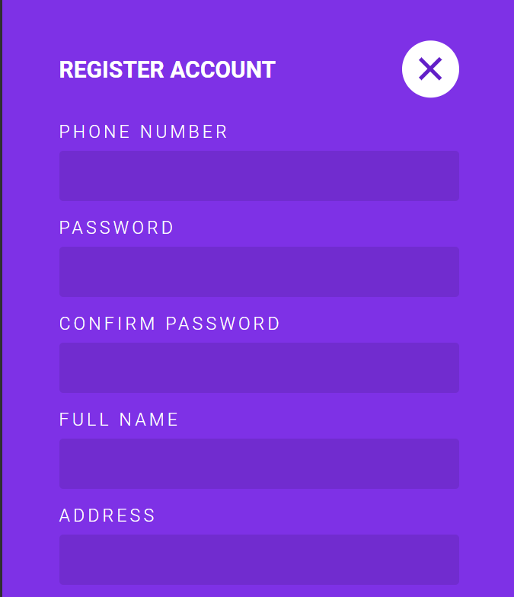

* *Function Details: User account must be logged in.*

## b. Login with registered account (phone and password)

* *Function trigger: Default login page.*
* *Function description: Users want to login by phone.*
* *Screen layout:*

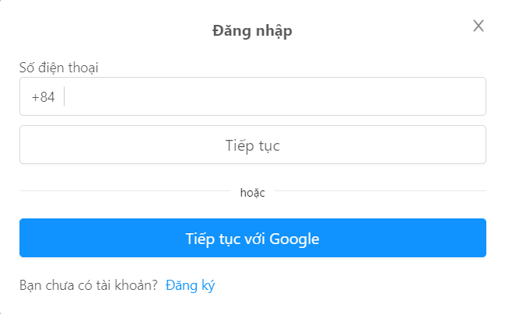

* *Function Details: Phone and password must be duplicated from phone and number in DB.*

## c. Login with Google

* *Function trigger: User wants to login by google account and clicks on the “Sign in with google”.*
* *Function description: Users want to use Google accounts for ease of convenience if they don’t want the hassle of phone registration.*
* *Screen layout:*

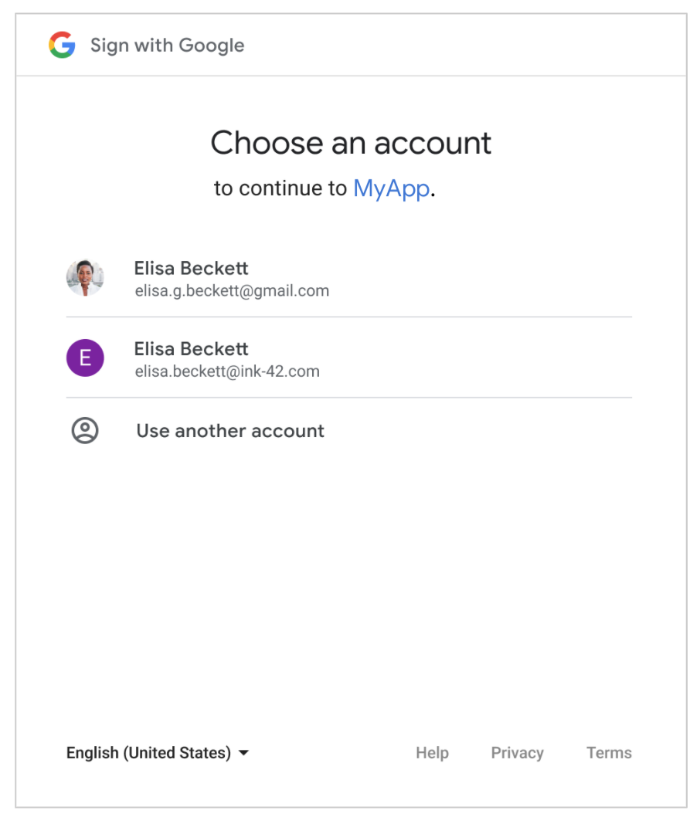

* *Function Details: Google account must be available*

## d. Logout

* *Function trigger: User wants to logout and clicks on the “log out” button.*
* *Function description: Users that have signed in can click the logout button exit or change account.*
* *Screen layout:*

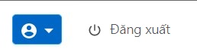

* *Function Details: User account must be logged in.*

## 

## 2. Purchase a trip or rent a car (customer)

## a. Buy ticket for a trip

* *Function trigger: Customer want to buy a ticket for a trip*
* *Function description: Customers choose vehicle, seat, route, date, time, place to be picked up then buy a ticket.*
* *Screen layout:*

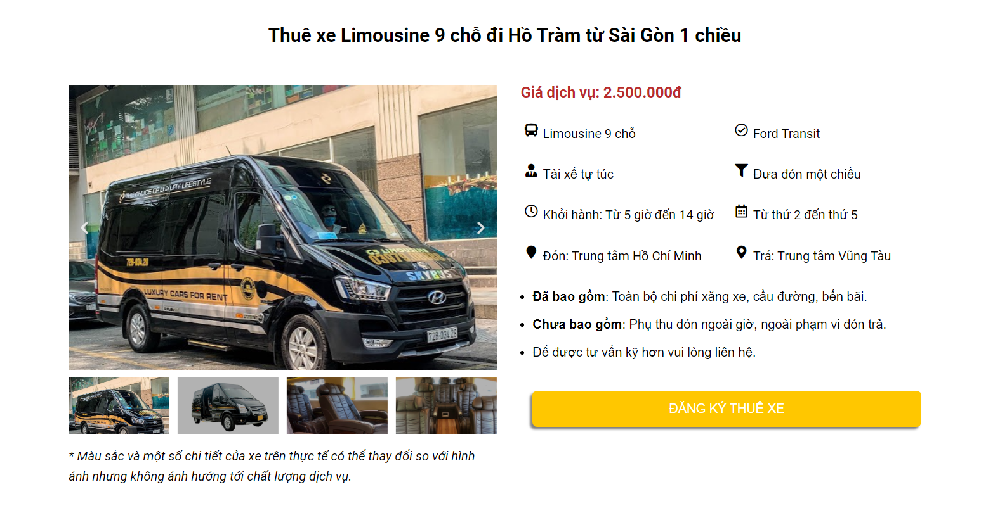

* *Function Details: The remainder of an account must be greater than the ticket price.*

## b. Rent a car

* *Function trigger: Customer wants to rent a car.*
* *Function description: Customers choose car type, manufacturer and time, date, place to pick up a vehicle with just a few clicks.*
* *Screen layout:*
* *Function Details: The remainder of an account must be greater than the rent price of the rented car.*

## 3. Manage Profile (Customer)

## a. Edit profile

* *Function trigger: Customers want to change their account's information.*
* *Function description: Customers can edit their information by logging in and clicking the change information button.*
* *Screen layout:*

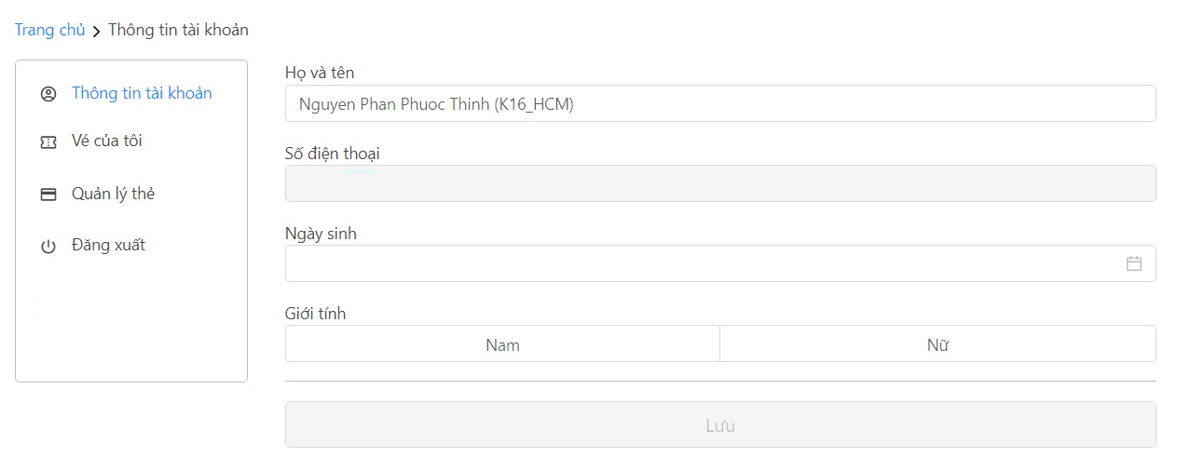

* *Function Details: Customer can edit full name, ID, date of birth, address, phone number,*

*email and password.*

## b. View payment history

* *Function trigger: Customer clicks on “My tickets”*
* *Function description: Customer want to view their rentals, tickets, payment history in detail*
* *Screen layout:*

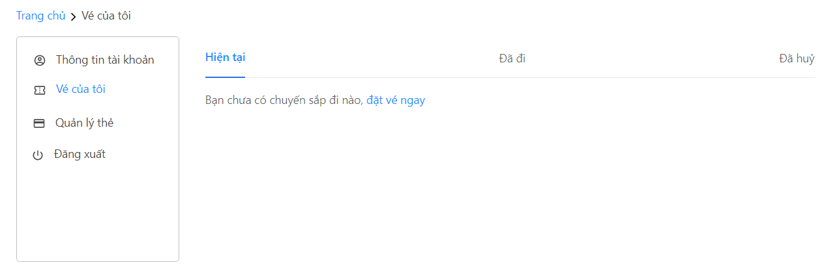

* *Function Details: Customers want to view their payment history in detail : current, past and cancelled tickets, car rentals.*

## 4. Manage Transport( Transportation Company)

## a. Manage trips

* *Function trigger: Transport companies want to manage the trips.*
* *Function description: Transport companies want to manage the trips.*
* *Screen layout:*
* *Function Details: Transport companies can view, search, create, delete, update trips.*

## b. Manage vehicle

* *Function trigger: Transport companies want to manage the vehicles and clicks on the “manage vehicle” button.*
* *Function description: Transport companies want to manage the vehicles.*
* *Screen layout:*

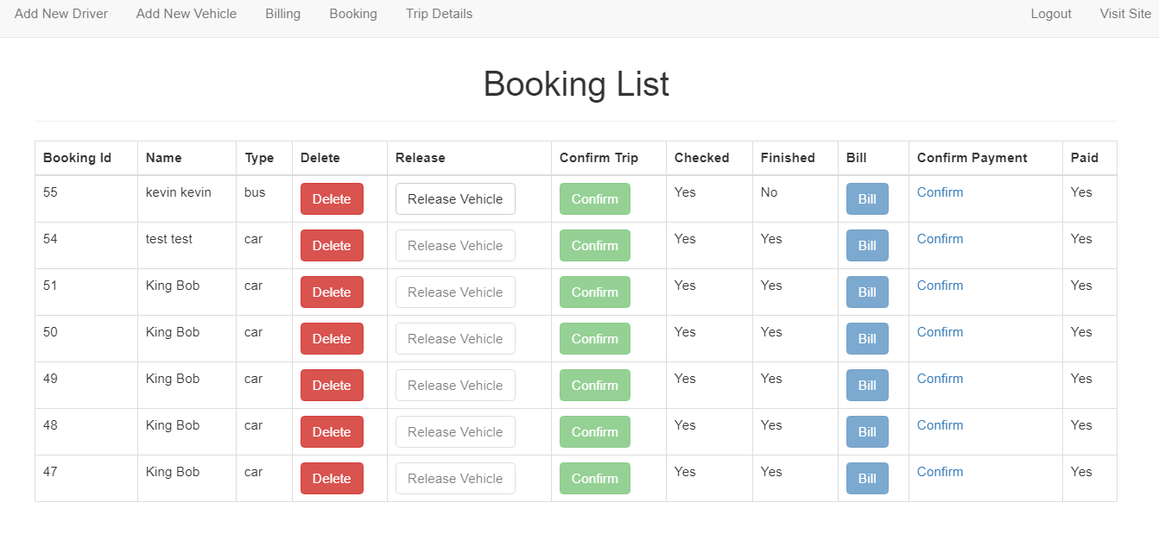

* *Function Details: Transport companies can view, search, create, delete, update the vehicles.*

## c. Manage ticket

* *Function trigger: Transport company wants to manage the tickets clicks on the “manage tickets” button.*
* *Function description: Transport companies edit pick-up destination, time, location, ticket price.*
* *Screen layout:*

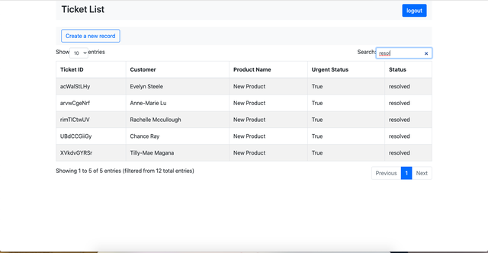

* *Function Details: Transport companies can view, search, create, delete, update tickets .*

## d. Manage rentals

* *Function trigger: Transport companies want to manage vehicle rentals.*
* *Function description: Transport companies want to manage vehicle rentals .*
* *Screen layout:*

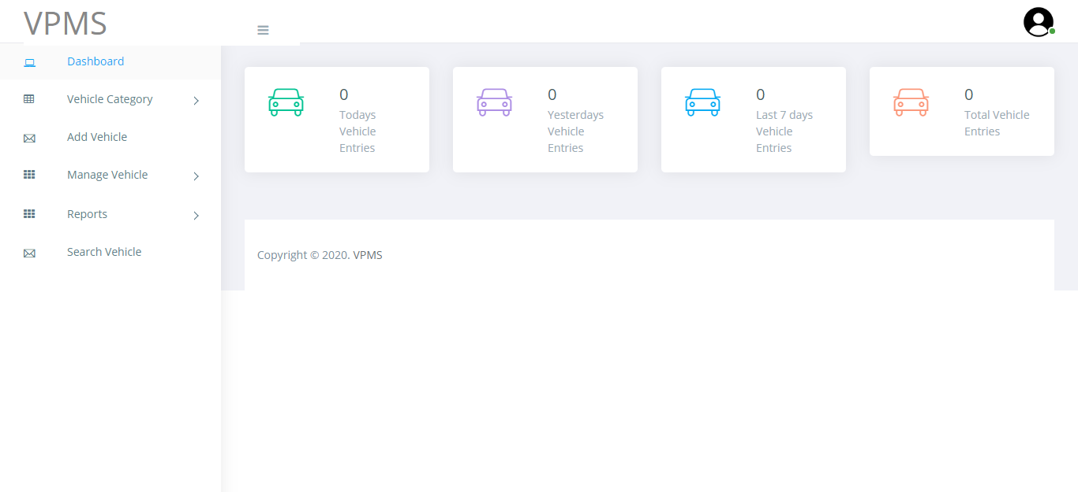

* *Function Details: Transport companies can view, search, create, delete, update vehicle rentals.*

## 5. Manage Accounts (Admin)

## a. View account

* *Function trigger: Admin logs in to automatically view all accounts, then can view all company accounts or customer accounts.*
* *Function description: Admin wants to view a list of account .*
* *Screen layout (demo):*

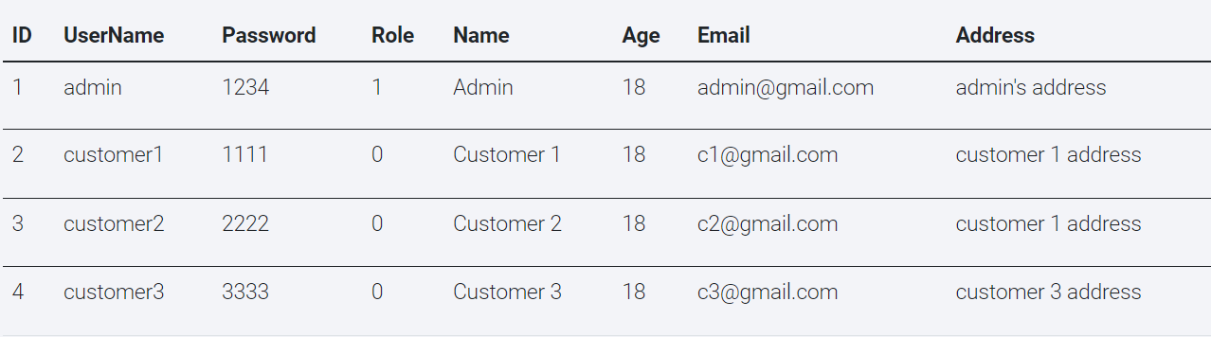

* *Function Details: List of accounts that admin wanted to view must be correct.*

## b. Search account

* *Function trigger: Admin hover on search box and type in name of accounts to search .*
* *Function description: Admin wants to search an account.*
* *Screen layout:*

**

* *Function Details: List of searched accounts must be valid to query.*

## c. Update account

* *Function trigger: Admin clicks the update button of an account.*
* *Function description: Admin wants to update an account.*
* *Screen layout:*

**

* *Function Details: Admin edits all fields of the accounts (id, name, roles …).*

## d. Delete account

* *Function trigger: Admin clicks the delete button of an account.*
* *Function description: Admin wants to delete an account.*
* *Screen layout:*

**

* *Function Details: Account must not be online, buying a ticket, in use of a ticket, renting a vehicle.*